Quiz 3 Environmental Biology 104 Summer 2021
Modules 5 & 6
102 points possible

READ THESE DIRECTIONS AND COMMENTS BEFORE TAKING THE TEST!

- Answer as clearly and concisely as you can. (Lists and bulleted points are acceptable). Please keep the text of the test with your answers.

- Put your answers in BOLD or in COLOR to keep them separate from the questions.

- Use your own words to answer the questions.

  - Since access to material cannot be controlled, this test is “open book” which means you may look at the Reading Assignments and Course Contents (Module Information) as you work on the quiz.

- This test must be turned in by midnight EST on Monday, July 19th.

Module 5 – Chesapeake Bay (CB) 52 pts

1. A. Define Estuary (2) –

B. True or False. Chesapeake Bay is the largest estuary in the United States. (1)

C. How large is the Chesapeake Bay watershed? (1)

D. Which states (and district) are found within the CB watershed? (2)

(6 pts)

2. From the food web diagram in the “Food Chain Structure” section: (5 pts)

A. List the 3 major sources of inorganic nutrients to producers within an estuarine system. (3pts)

B. Put the following terms in a correct cycle: producers, decomposers, inorganic compounds, organic compounds. (Since it is a continuous cycle, you may start with any of the terms, but you must put the remaining terms in the correct order.) (2pts). (Your answer should have this format: Starting term flows to second term flows to third term and then goes to fourth term which goes back to starting term.)

3. A) There are two main reasons that most estuaries have high biodiversity. What are those two reasons? (2pts)

B) True or False. In a specific area of the bay, abiotic conditions will be almost constant from day to day during a particular season. (1pt)

C) The salinity of the water within the bay varies along the length of the bay. Give typical salinity for the upper parts of the bay _____ ppt and for the mouth of the bay ______ ppt. (2pts)

D) What natural event could cause an overall depletion of the salinity of the bay? (1pt)

E) Dissolved gases in the waters of the bay vary more ____(1pt).
(Choose one: A. across the width of the bay or B. along the length of the bay)

(7 pts Total)

4. List 4 actions mentioned in the Module 5 content that farmers that live within the CB watershed can do to limit negative agricultural impacts on the waters of CB.
(4 pts)

5. What are three (distinct) major threats to oyster populations within CB? (3pts)

6. Water Quality of the Chesapeake Bay

A. List 4 major factors that have caused the reduction in water quality within CB.
(4pts)

B. List three consequences (results) of reduction in water quality within CB.
(3pts)

C. In your opinion which of the above is the most serious consequence (result)? __________________ Explain why.
(This is an opinion question…you won’t find a “correct” answer in the content. You just need to tell me what you think and explain your reasoning.). (2pt)

D. Explain why the loss of oysters is a CAUSE of reduction in water quality. (1pt)
(10 pts Total)

7. Marshes and other communities near the bay physically “protect” the aquatic environment in different way. List 3 distinct ways through which the protection occurs. (3 pts)

8. A. Name two invasive species (discussed in the Module’s content) that are
threatening CB. (2pts)

B. Explain the damage that each of these organisms does to the bay. (2pts)

9. Module 5 Reading Assignment #2.
https://www.cbf.org/about-the-bay/state-of-the-bay-report/index.html
All the below answers should come from the reading and not from other sources. (7 pts)
- In 2020 what was the average health index score of the bay? ______pts out of 100. (1)

- Pollution, Habitat and Fisheries are the 3 major categories for the indicators of bay health. List the 4 individual indicators within each category. (3)
(You must list all of the correct indicators in a category to earn the point) Pollution Habitat Fisheries __________ ___________ ___________ __________ ___________ ___________ __________ ___________ ___________ __________ ___________ ___________
C. What was the main reason why the score for the Bay from 2018 to 2020 reduced by one point? Explain why this occurred (There are three main reasons). (3pts)

10. Module 5 Reading Assignment #1: https://www.chesapeakebay.net/news/blog/chesapeake_bay_blue_crab_population_remains_healthy_and_sustainable_despite

Summarize the status of the blue crab population in Chesapeake Bay in 2020 by answering the following questions:

  - What was the change in population size from 2019 to 2020?
  - Is the population being overfished?
  - What do they think caused the wintering mortality of juveniles between 2019 and 2020 to be low?

(3 pts)

Module 6 – Great Lakes (GL) 50 pts

1. The abiotic conditions found within a lake are determined largely by three or four factors. List at least three of those factors. (Note: I’m NOT asking for the abiotic conditions within the lake) (3 pts)

2. A. List the 4 zones found in large lakes. (4pts)

B. Which of the above zones would always have low light levels? (Be careful with this one; there is only one right answer.) (1pt)

C. List at least 4 abiotic factors that often vary between the surface and the depths of a deep lake when the water column is stratified. (2 pts)

(7 pts total)

3. A. List the names of the Great Lakes according to size (Use volume not surface area, for size determination). (2.5pts)

B. Which Great Lake has the longest retention time? (1pt)

C. Which Great Lake has the shortest retention time? (1pt)

D. Approximately, how large is the watershed for the entire Great Lakes? (1pt)

E. Name the three Great Lakes that have experienced the greatest increase in human population in their basins over the last 100 yrs. (1.5pts)

(7 pts total)

4. From the “Why are the Great Lakes Great?” section – Land Use Diagram: (8 pts)
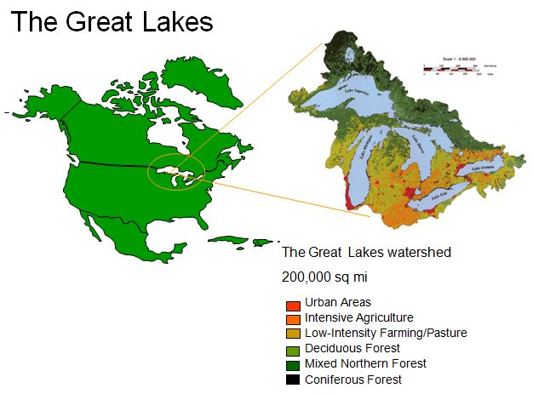
A. List 3 different land “uses” seen in the watershed of the Great Lakes.[Note: There are 6 designations on the diagram but some of them are similar to each other.] (3)

B. List the 3 main threats to the Great Lakes that were described in the module content. (3)

Out of the three, which do you see as the most serious? __________ Explain your answer. (This is an opinion question…you won’t find a “correct” answer in the content. You just need to tell me what you think and explain your rationale.) (2)

5. Module 6 page 11 “More recent and current issues” - From chart (bottom) “Major Water Pollutants and Their Sources and Their Impacts”.
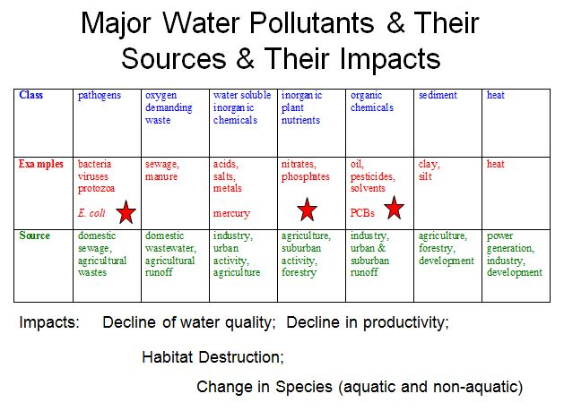
A. List 6 classes of pollutants that are found in the Great Lakes. (3)

B. Name 3 specific examples of pollutants that come from industrial sources. (1.5)

C. Name two sources of pathogens found in the Great Lakes. (1)

D. Name one source of heat pollution in the Great Lakes (0.5)
(6 pts)

6. Bioaccumulation (5 pts)
A. Explain in detail how certain animals can have extremely high concentrations of a toxin within their systems even though the level of that toxin in the environment is very low. (2)

B. Why do some toxins bioaccummulate and others do not? (2)

C. As a terrestrial organism, how do humans get affected by these toxins that are found in aquatic environments? (1)

7. List 4 possible ways in which transport of invasive species by ballast water of ships can be prevented.

(2pts)

8. What are two major ways in which the challenge of remediation and conservation of the Great Lakes region differs from the challenge of remediation and conservation of the Chesapeake Bay. (4 pts)

[Note: This concept was not stated specifically in any of the module content or reading assignments. Consider what you know about each ecosystem and its problems and then state a couple of differences. I do have two specific differences that I am looking for but as long as your differences are relevant and accurate and different enough from each other then you will be given credit for your answers.]

9. There are many Areas of Concerns (AOCs) within the Great Lake watershed.
Thoroughly explain what an AOC is and explain why there are so many AOCs found within the Great Lake watershed? (4pts)

10. Designate for each of the statements below whether they are True or False. (4 pts)
- In certain AOC's in the Great Lakes, positive changes in the health of the environment were associated with an increase in community collaboration. True or False
- The Great Lakes pollution problems were created by the industrial and agricultural revolutions in both the 19th century and 20th century. True or False
- Long term exposures to toxic algal blooms have been linked to disorders such as Parkinson’s disease. True or False
- Harmful algal blooms in Lake Erie are primarily caused by a Microcystis cyanobacteria. True or False

Bonus Questions (worth up to 5 pts)

(Answers to these questions won’t be found in the Module content or in the Reading Assignments. Use recent online sources)

- Is the Chesapeake Bay Dead Zone in 2021 predicted to be bigger than normal, normal size, or smaller than normal? (1)

- Which state in the CB watershed is the farthest behind in achieving pollution reduction goals? (1)

- Why is there a blue crab shortage in Maryland this year? (2)

- What are the impacts of that shortage? (1)

